TrailheaDx - Computer Setup – Trailhead Workshops

# Computer Hardware

Ensure there is a label on the laptop screen with a number on it. (001 – 100) * Each room should begin with 001 through however many computers are in the room.

Please confirm that the TrailheaDX Background Image is on all the computers.

# Shortcuts

Verify that these shortcuts are on the desktop:

|  |  |
| --- | --- |
| * Google Chrome | * Data Loader |
| * Mozilla Firefox | * Notepad++ |

# Bookmarks

1. Open all three browsers (Google Chrome, Mozilla Firefox, and Internet Explorer) and verify that the home page is [www.salesforce.com](http://www.salesforce.com)

2. Verify that the sites below are **bookmarked** and that they launch successfully:

|  |  |  |
| --- | --- | --- |
| Google  Chrome | Mozilla  Firefox | Link / URL |
| Salesforce login | Salesforce login | <https://login.salesforce.com/> |
| Session Survey | Session Survey | <https://sfu.getfeedback.com/r/2A5pEzDU> |
| TDX Site | TDX Site | <https://developer.salesforce.com/trailheadx> |
| Mimeo Ebook | Mimeo Ebook | [https://salesforce.mimeo.digital/](https://t.yesware.com/tt/2f0e3321852c45edd504cdd4618e527b282bd71a/dbc68cb1c74c04e2fedde2c4d7437d3e/8d537a697b1f9b0f165a392189aa7566/salesforce.mimeo.digital/#/login) |

Please Verify the following Applications are installed on the computer.

# Applications

## Data Loader

1. Double-click on the **Data Loader** icon on the desktop.

2. Verify that the program launches.

3. Close the application.

## Notepad ++

1. Double-click on the **Notepad++** icon on the desktop.

2. Verify that the program launches.

3. Close the application.

To verify Java JDK and ANT **(Java needed for App Builder Course Room TradeWinds D and E-F) Architect Track needs both Java and ANT (Room Islander I) **again if not checking in either of these 3 rooms you can skip this step.**

Go to Windows Icon (lower left hand area of computer) right click choose command prompt

type in the following:

java –version (press enter) and to verify Ant type in ant –version press enter you should see the following:

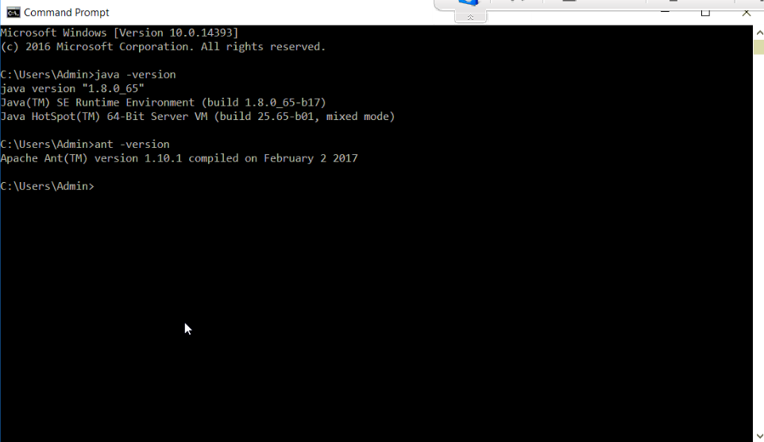

IF THERE IS ANYTHING MISSING PLEASE PUT THE LID OF THE COMPUTER DOWN AND PUT A STICKY NOTE ON THE TOP OF THE LAPTOP VERIFYING WHAT IS MISSING.